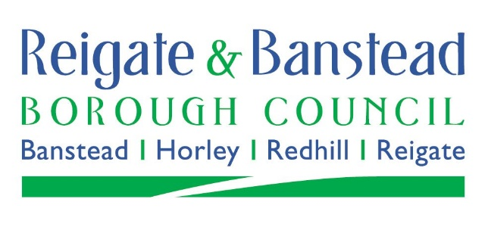
Annexe discount application form
Please complete EITHER Part 1 or Part 2 of this form as relevant if you wish to apply for the 50% reduction in the Council Tax payable on your annexe.

Part 1: Is the annexe used as part of the household as a whole? Yes / No

Part 2: Is the annexe occupied by a relative of at least one of the people occupying and liable for Council Tax on the main home? Yes / No

If Yes, please complete below:
Name/s of the person/people liable for Council Tax on the main house:
Contact details (Email address and/or telephone number):
Address of the main house:
Name/s of the person/people occupying the annexe:
Contact details (Email address and/or telephone number):
Address of the annexe:
Relationship to the person/people liable for Council Tax on the main house:
Signed:
Dated:

Please return this application form to: council.tax@reigate-banstead.gov.uk or Council Tax Department, Reigate & Banstead Borough Council, Town Hall, Castlefield Road, Reigate, Surrey, RH2 0SH

